**Group Project**

**Topic :- Retail Store ( Billing )**

**Group Members – Group-6**

**(1) Yash Moses 18BCA001**

**(2) Shubham Singh 18BCA010**

**(3) Aman Kesharwani 18BCA033**

**Course :- BCA 4th Semester**

**Subject :- Programming with JAVA ( CSIT-423 )**

**Submitted to – Vineesh Cutting Sir.**

**Class Diagram :-**

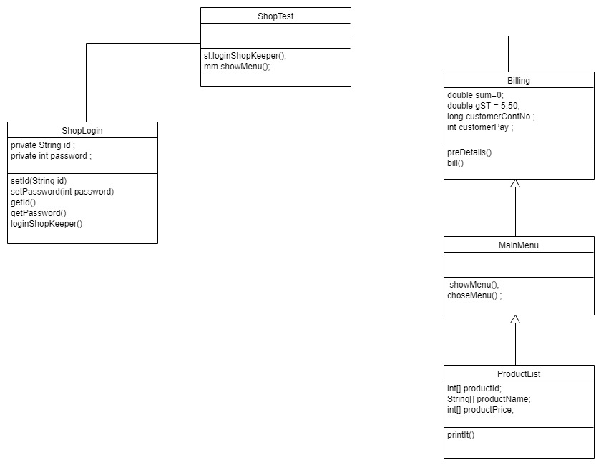

Retail Shop Billing System

The Retail Shop Billing System is used for the billing purpose of a retail shop ,making the billing easy and accurate.

The program is based on JAVA and has successfully tested.

The program has been arranged in a Multi-Level Inheritance form So that A code can be used again and again

The Program starts With a Login Screen Where the System asks for Login ID and Password from The user.

The ShopLogin Class carries the requirements of login details and also has encapsulation for security purposes.For Wrong attempt the program won't run.

Next after logging into the program We have

the MainMenu Class which shows the main menu operations that can be performed such as Billing,

Product list and logging out operation.It takes user input to execute different operations.

The Billing Class stores the pre-bill details that is the name of the retail shop,address of the retail shop and GIST number and also asks for customer number for customer detail which will be stored.

Billing class also consists of a Bill function which will be used to calculate the bill on the basis of quantity and rate of the products.

The ProductList class carries the name of the product,price of the product and product ID in an array to show the product details whenever the user operates for the product list or wants to know the product detail(price,id,name)

Then we have the ShopTest Class where all the objects are called to execute the program for the The Retail Shop Billing System .